Buying Tokens at Open

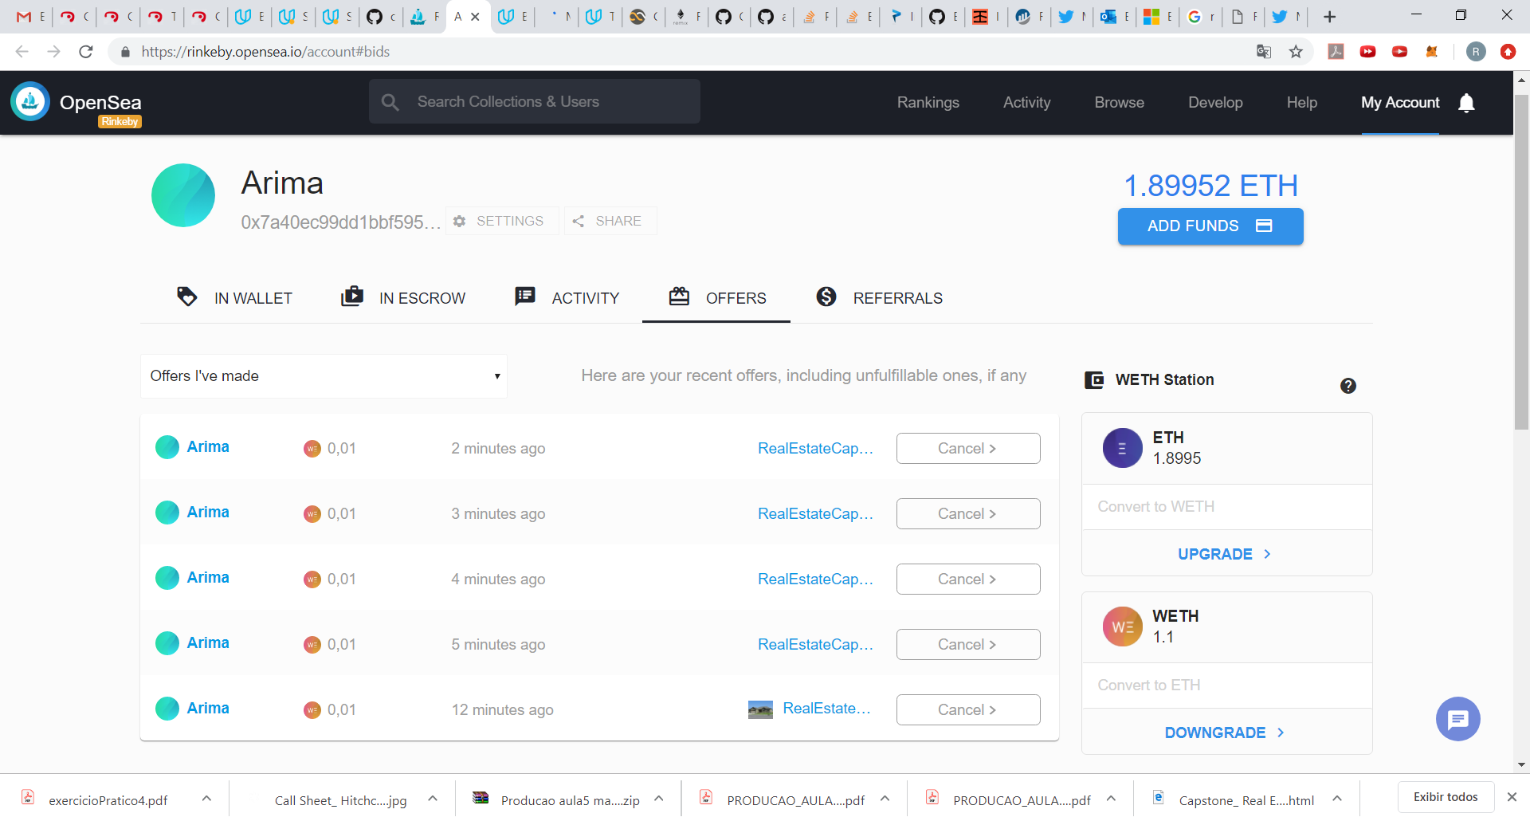

5 Tokens at OpenSea

https://rinkeby.opensea.io/assets/0x48e1a17847e10c8104f666f8c280bc29ce29dfb0/1

https://rinkeby.opensea.io/assets/0x48e1a17847e10c8104f666f8c280bc29ce29dfb0/10

https://rinkeby.opensea.io/assets/0x48e1a17847e10c8104f666f8c280bc29ce29dfb0/20

https://rinkeby.opensea.io/assets/0x48e1a17847e10c8104f666f8c280bc29ce29dfb0/30

https://rinkeby.opensea.io/assets/0x48e1a17847e10c8104f666f8c280bc29ce29dfb0/40

<https://rinkeby.opensea.io/assets/0x48e1a17847e10c8104f666f8c280bc29ce29dfb0/50>

CONTRACT Rinkeby

<https://rinkeby.etherscan.io/address/0x48E1a17847e10C8104F666f8c280bc29cE29dFB0>

Account Mint and put on sell

<https://rinkeby.etherscan.io/address/0x3997Dbdb7dBc5E1432071a07cfFA2EDef608d15a>

Account Buy 5 Tokens

<https://rinkeby.etherscan.io/address/0x7A40ec99dD1BBf595439029c6162b2f0996E34d3>